Truncated Octahedron

Definition
# Source: AI Source: Provided by: [Data Path: Persons Table -> ID Column: 1, Name_En Column: Motasem Essam] -> From: [ChatGPT] on [7/25/2026]
A Truncated Octahedron is a three-dimensional polyhedron formed by cutting off the six vertices of an original octahedron using planes.
The truncation process creates six new square faces while modifying the original eight triangular faces into hexagonal faces.
A uniformly truncated octahedron is an Archimedean solid.

Geometric Structure
# Source: AI Source: Provided by: [Data Path: Persons Table -> ID Column: 1, Name_En Column: Motasem Essam] -> From: [ChatGPT] on [7/25/2026]
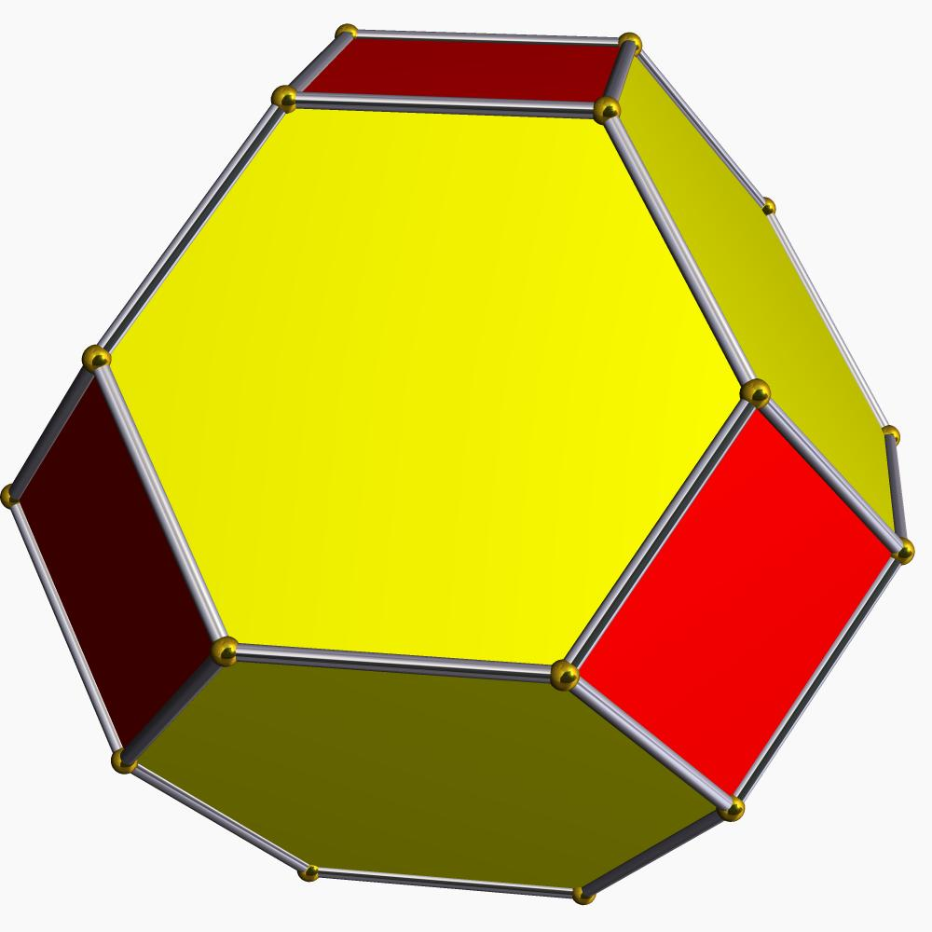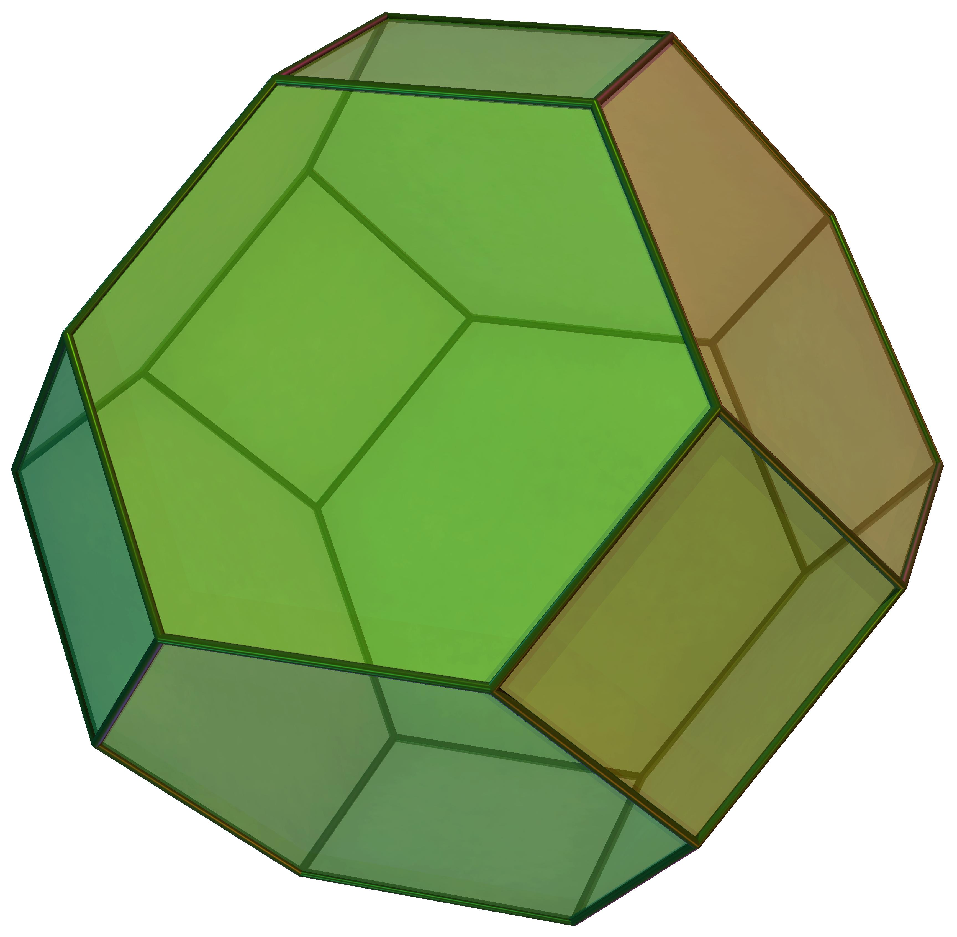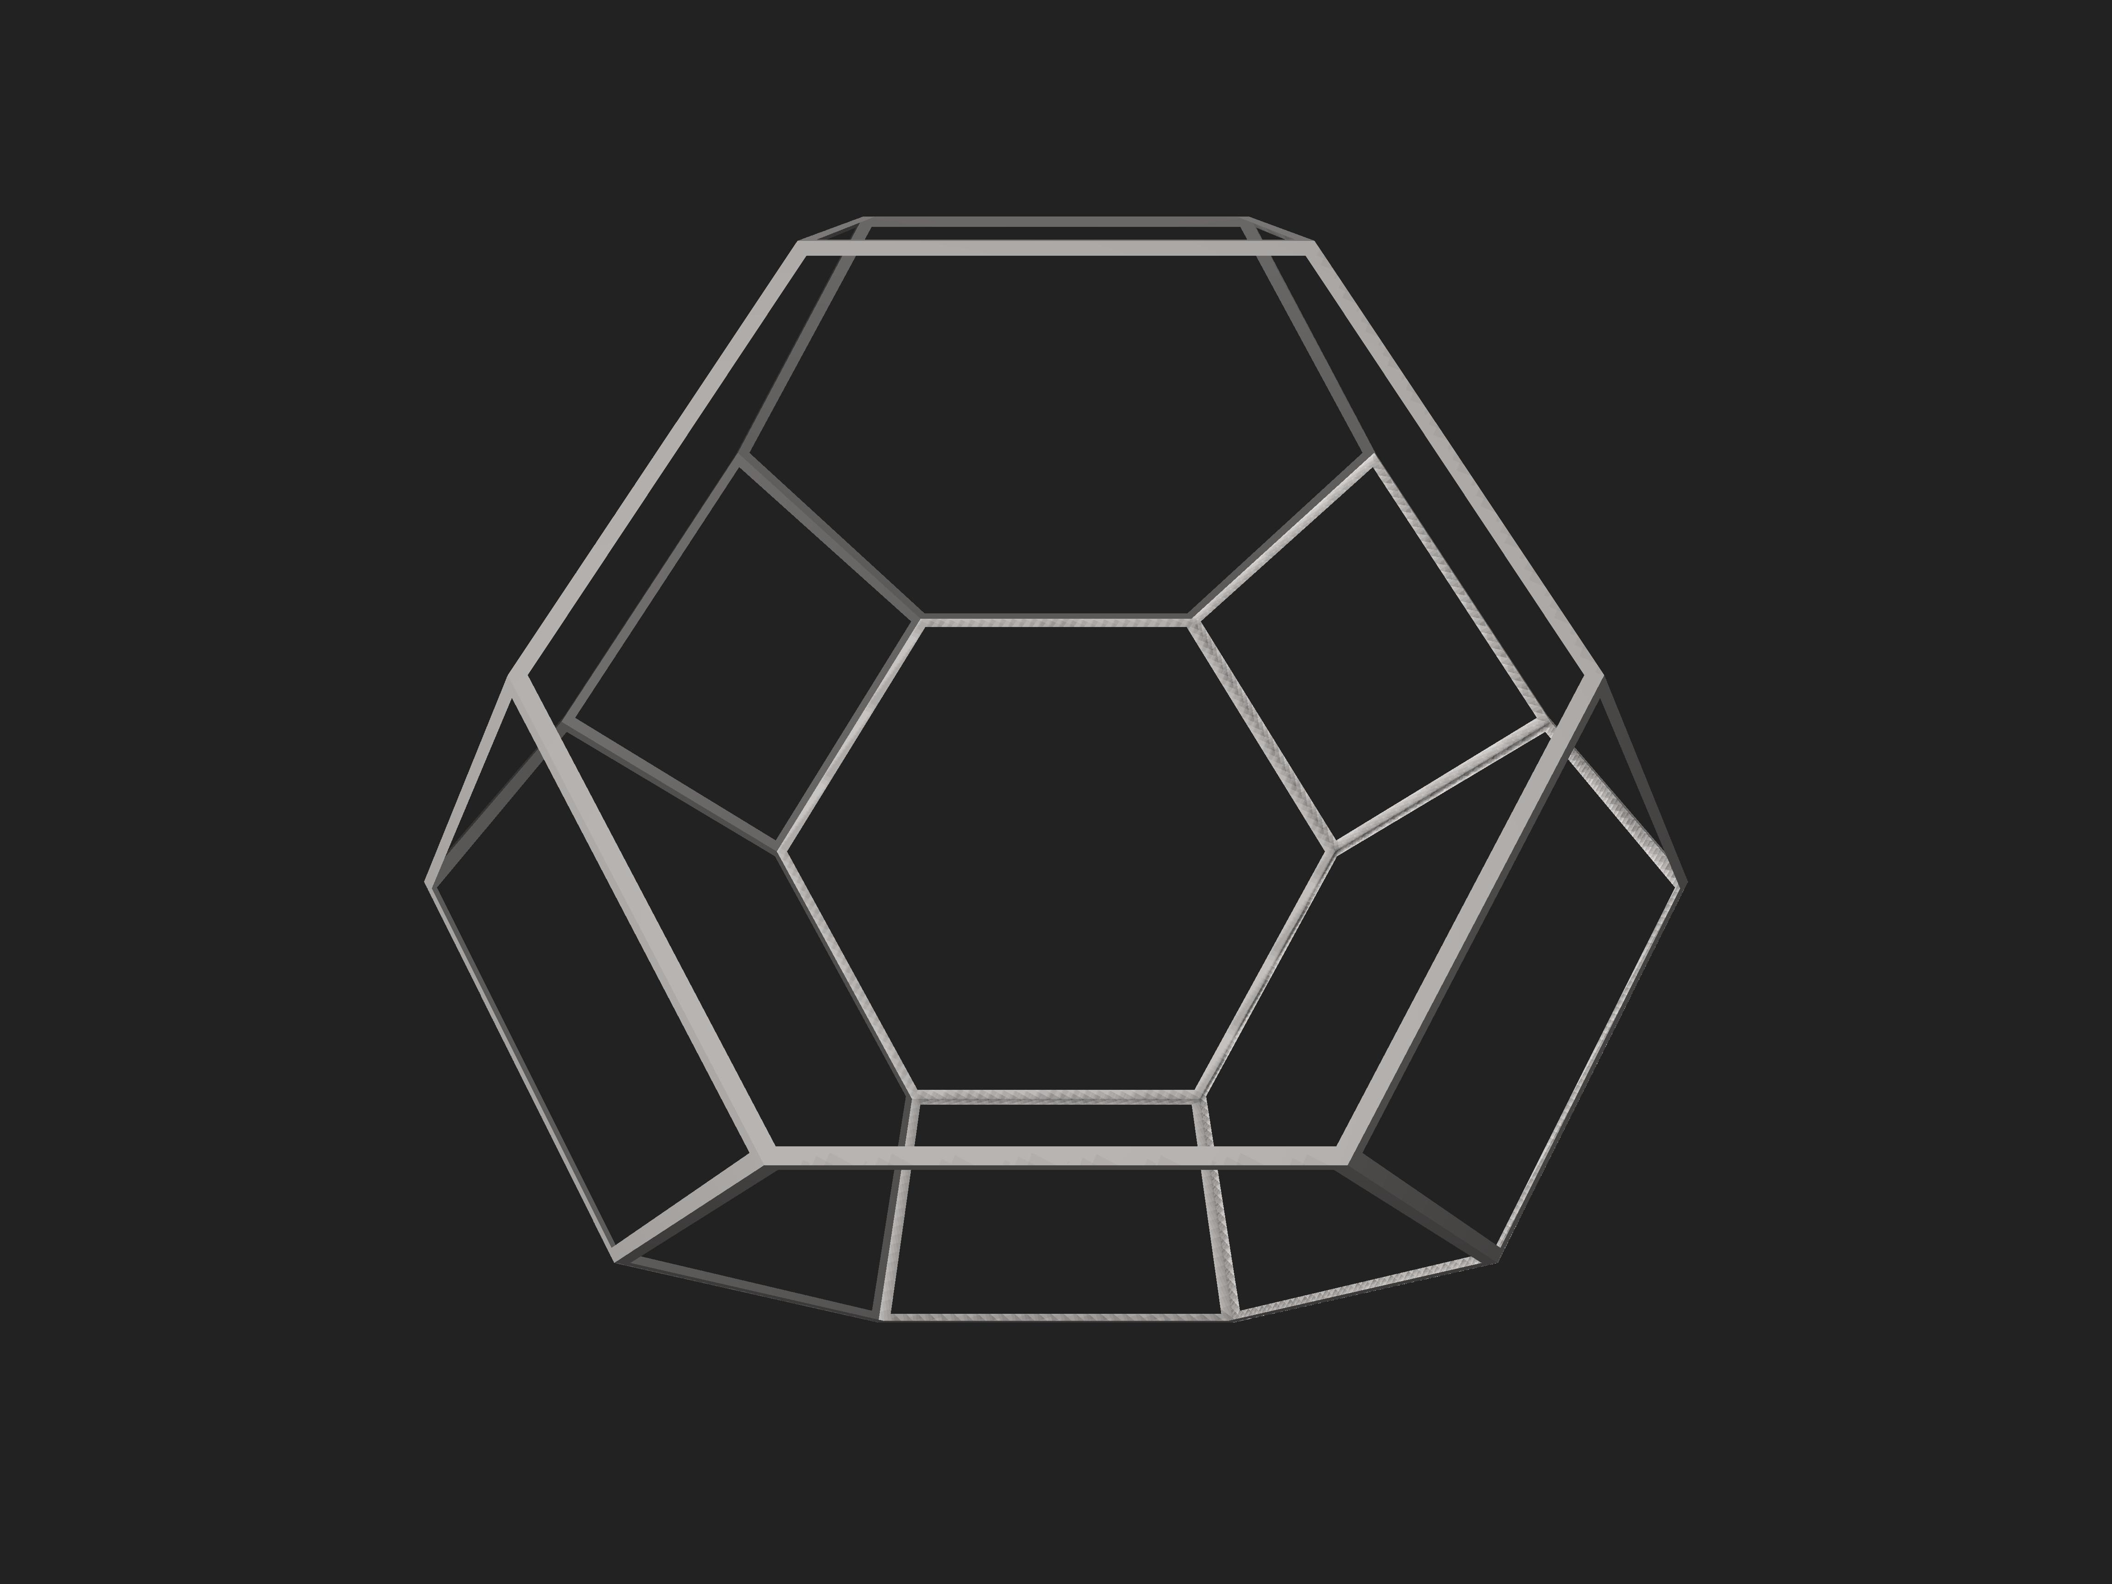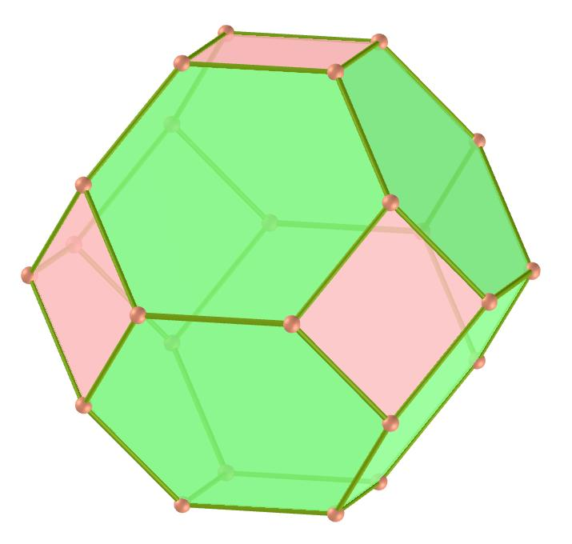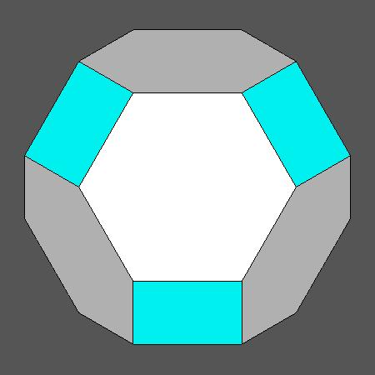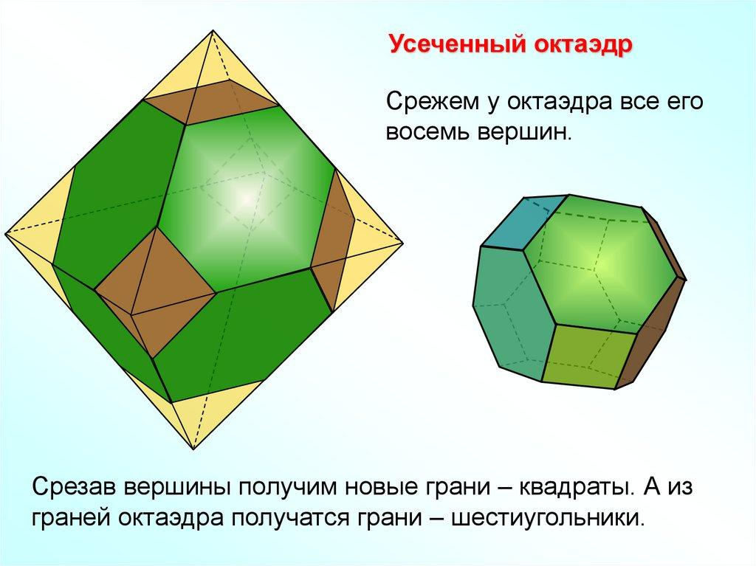
A truncated octahedron consists of:
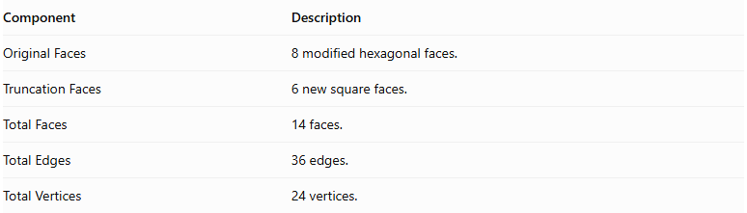
Component | Description
Original Faces | 8 modified hexagonal faces.
Truncation Faces | 6 new square faces.
Total Faces | 14 faces.
Total Edges | 36 edges.
Total Vertices | 24 vertices.

Face Composition
# Source: AI Source: Provided by: [Data Path: Persons Table -> ID Column: 1, Name_En Column: Motasem Essam] -> From: [ChatGPT] on [7/25/2026]
The truncated octahedron contains two types of polygonal faces:
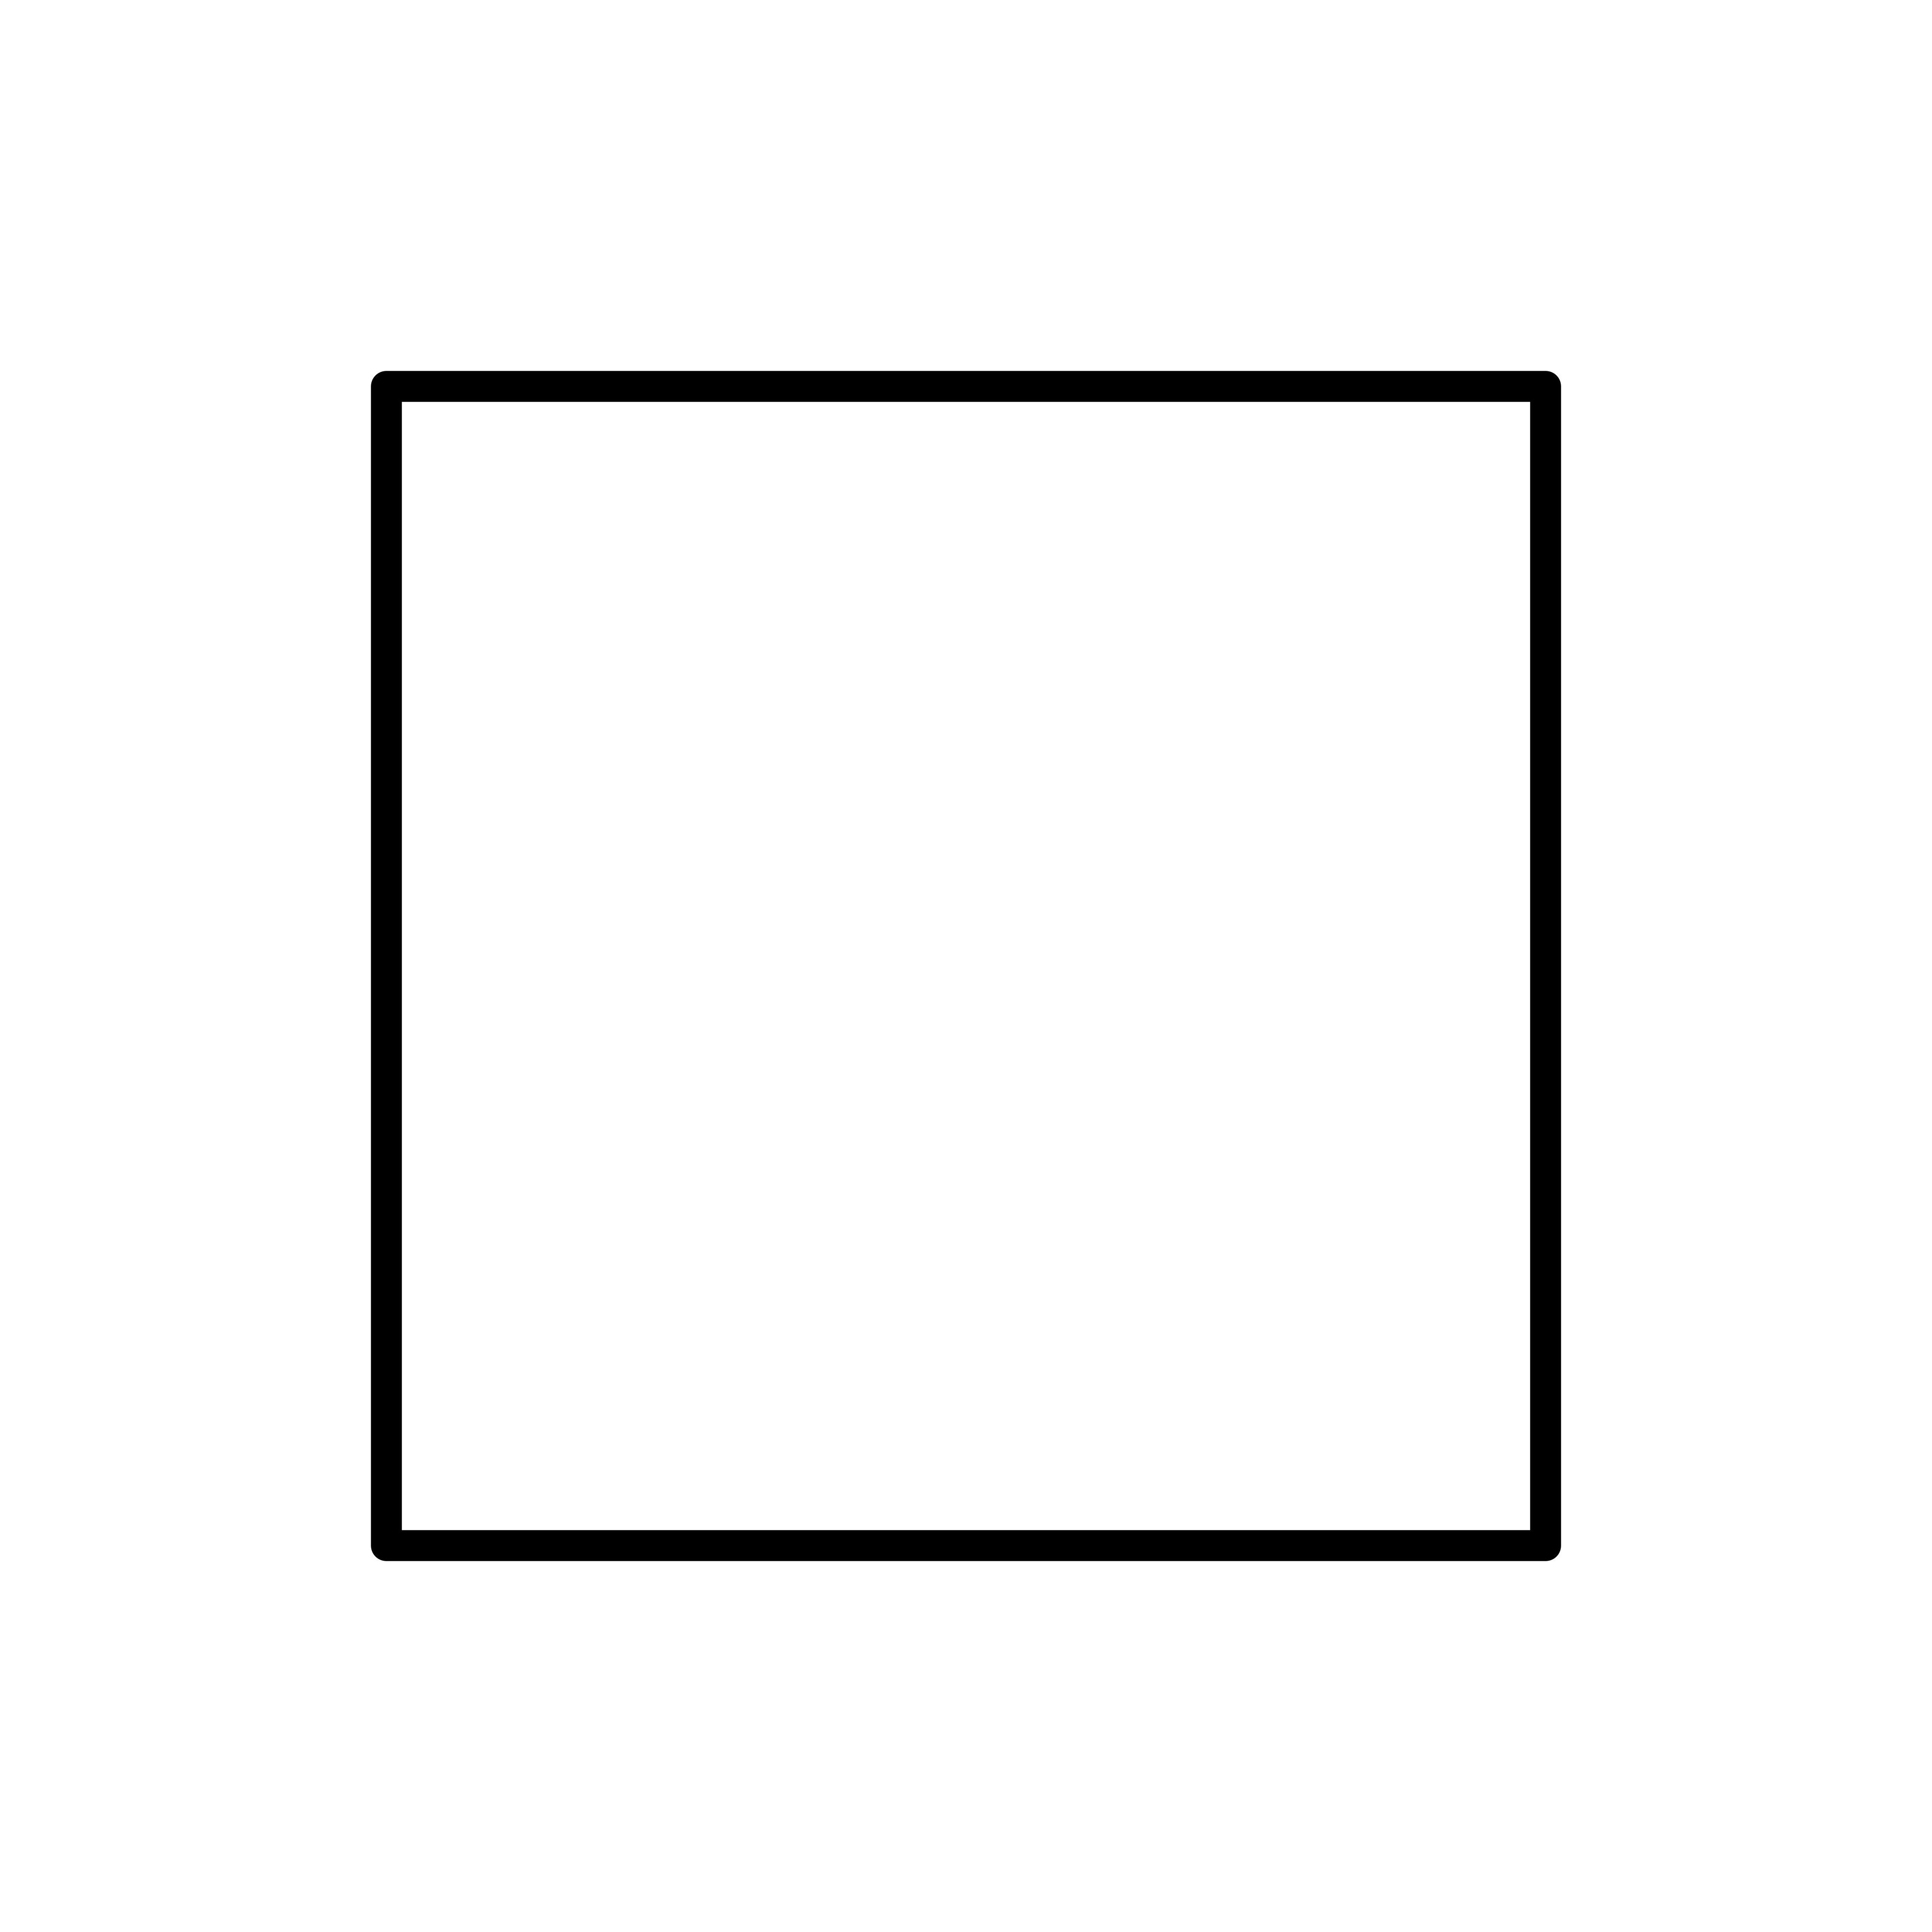

Square Faces
# Source: AI Source: Provided by: [Data Path: Persons Table -> ID Column: 1, Name_En Column: Motasem Essam] -> From: [ChatGPT] on [7/25/2026]
- Number: 6
- Shape: Squares.
- Origin: Created by truncating the six original vertices.
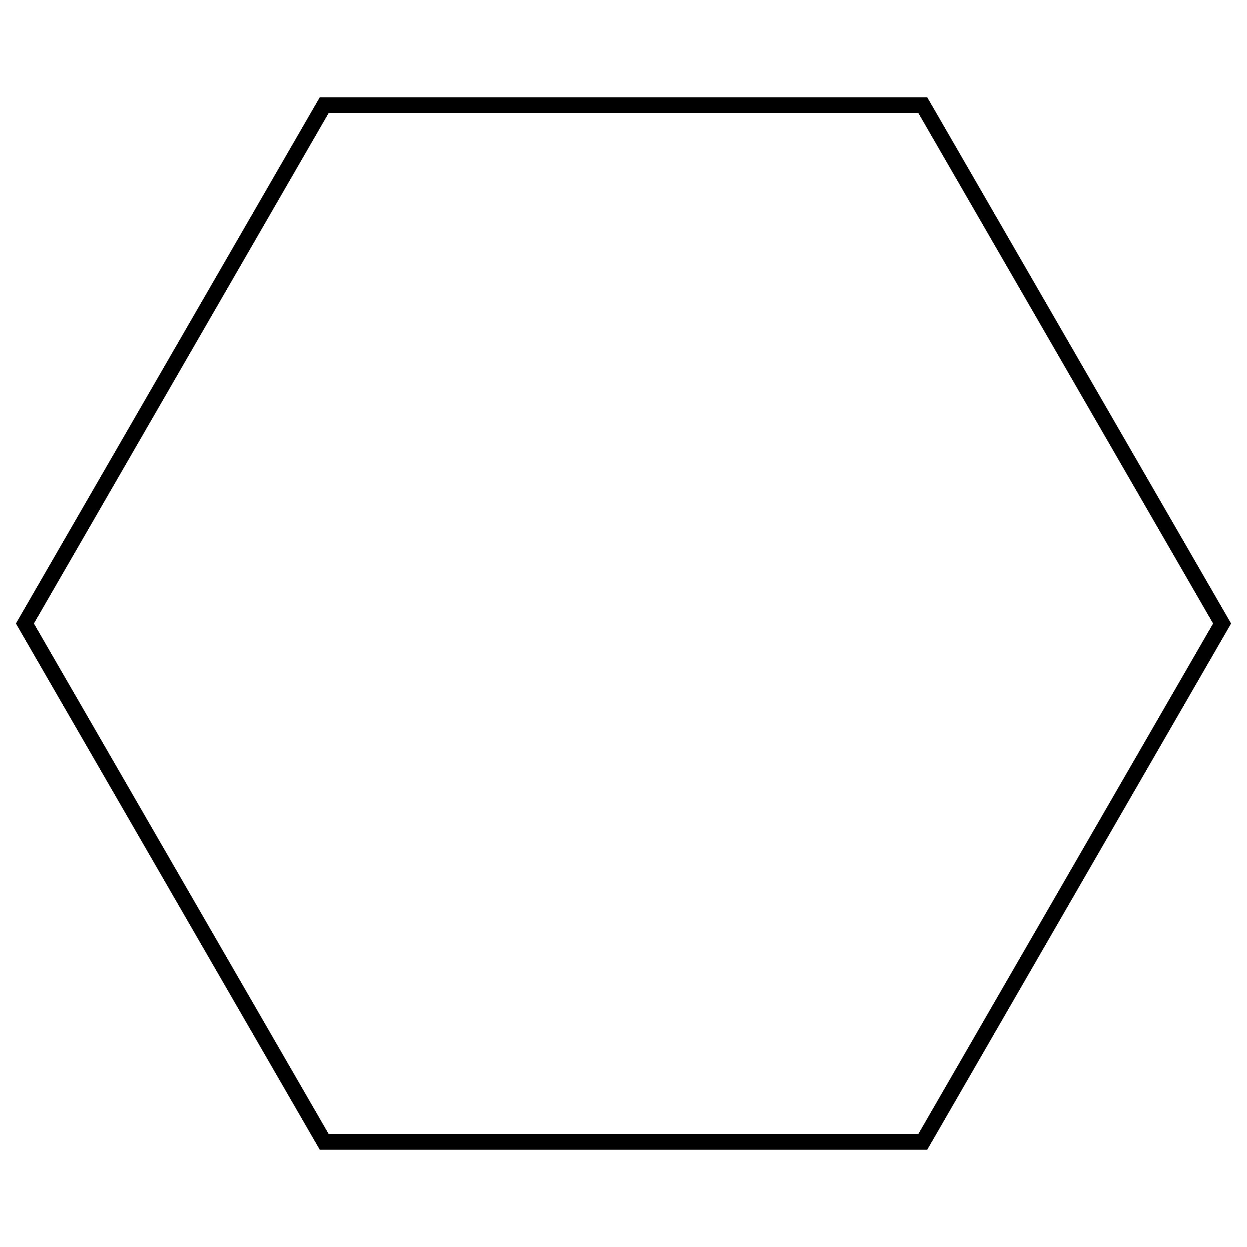

Hexagonal Faces
# Source: AI Source: Provided by: [Data Path: Persons Table -> ID Column: 1, Name_En Column: Motasem Essam] -> From: [ChatGPT] on [7/25/2026]
- Number: 8
- Shape: Regular hexagons.
- Origin: Modified from the eight original triangular faces.

Mathematical Properties
# Source: AI Source: Provided by: [Data Path: Persons Table -> ID Column: 1, Name_En Column: Motasem Essam] -> From: [ChatGPT] on [7/25/2026]
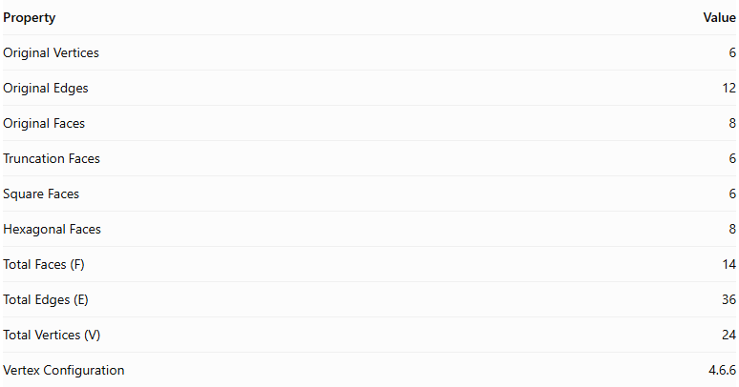
Property | Value
Original Vertices | 6
Original Edges | 12
Original Faces | 8
Truncation Faces | 6
Square Faces | 6
Hexagonal Faces | 8
Total Faces (F) | 14
Total Edges (E) | 36
Total Vertices (V) | 24
Vertex Configuration | 4.6.6
Euler's Formula:
$$V-E+F=2$$
Substituting:
$$24-36+14=2$$
Therefore, the truncated octahedron satisfies Euler's formula.

Key Points
# Source: AI Source: Provided by: [Data Path: Persons Table -> ID Column: 1, Name_En Column: Motasem Essam] -> From: [ChatGPT] on [7/25/2026]
- It originates from a regular octahedron.
- All six original vertices are truncated.
- It has 6 square faces and 8 regular hexagonal faces.
- It contains 36 edges and 24 vertices.
- It is an Archimedean solid when uniformly truncated.
- Its faces are regular polygons.

Conclusion
# Source: AI Source: Provided by: [Data Path: Persons Table -> ID Column: 1, Name_En Column: Motasem Essam] -> From: [ChatGPT] on [7/25/2026]
The Truncated Octahedron is an Archimedean solid formed by uniformly truncating the six vertices of a regular octahedron. It consists of six square faces and eight regular hexagonal faces, with a total of 14 faces, 36 edges, and 24 vertices.

